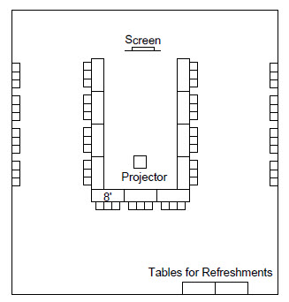
WESTERN DISTRICT BOARD MEETING

Date and Time
- Sunday
- Typically 9:00 am to 5:00 pm

Function Attendance
- TYPICALLY ABOUT 30-40

Room Set up
- U-shaped for 28 seated on outer sides of tables only (see diagram)
- End table if needed (shown dashed)
- Chairs each along two walls.
- One easel outside of room

Food & Beverage
Selected in consultation with Western District President.
May include:
- Morning
  - Pastries, fruit
  - Coffee, decaf, tea
- Lunch
  - Deli Buffet Lunch, or
  - Boxed Lunches
- Afternoon
  - Assorted Soft Drinks
  - Cookies, brownies

Assumes 8 ft. tables, 3 per table, with seats set to not straddle table legs U-shaped for 28 seated on outer sides of tables only (end table if needed (shown dashed) Officer Seating Refreshment/Buffet Tables Easel Open end provides position for standing presentations (or screen for visual). Overhead Projector and table, if needed.

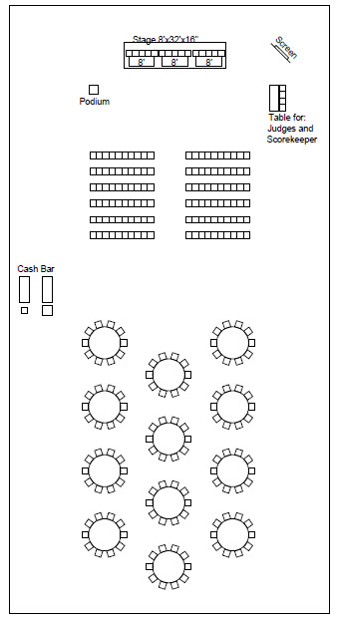
TRAFFIC BOWL

Date and Time
- Monday
- Typically Noon to 2:00 pm

Function Attendance
See historical data for ranges

Room Set up
- Spectators
  - Rounds of 10
  - Chairs for seating, or
  - Combination of both
- Three tables on risers (each table to
seat 5)
- Freestanding podium for Emcee
- Table for the judges (three seats)
- Cash Bar
- Tables for food
- One easel outside of room

Audio/Visual
- Emcee podium microphone
- Overhead projector package
  - Projector
  - Cart
  - Screen
  - All electrical cables and cords
- Speakers and amplifiers
- Traffic Bowl Equipment

Food & Beverage:
Selected in consultation with LAC Chair President.
May include:
- Ice Cream Bar or Pizza Bar
- Beverages (optional)

LEADERSHIP BREAKFAST
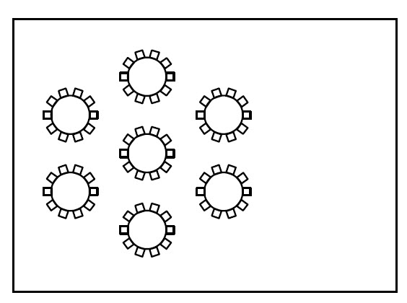

Date and Time
- Tuesday
- Typically 7:00 am to 9:00 am

Function Attendance
See historical data ranges

Room Set up
- Rounds of 10
- No Head Table
- One easel outside of room.

Audio/Visual
- Typically none

Food & Beverage:
Selected in consultation with Western District President.
May include:
- Breakfast buffet or sit down hot entree
- Coffee, decaf, tea

KICKOFF AND ANNUAL BUSINESS MEETING LUNCHEONS

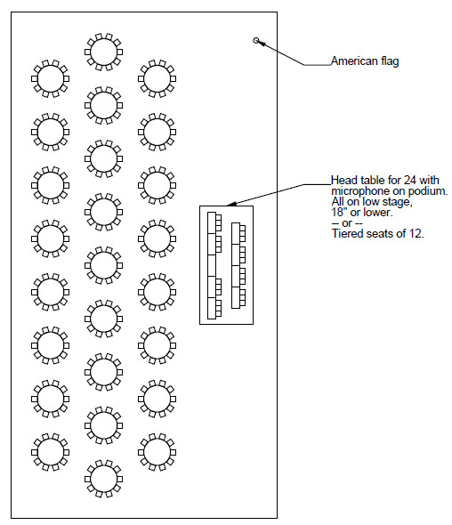
Date and Time
- Tuesday
- Typically Noon to 2:00 pm

Function Attendance
- See historical data ranges

Room Set up
- Rounds of 10
- Head table on low risers to seat up to 24 (likely 10 on Monday, 15+ on Tuesday)
- Table top lectern w/microphone adjacent to President at head table
- One American Flag on left at riser
- One easel outside of room.

Audio/Visual
- Presidential podium microphone
- Overhead projector package
  - Projector
  - Cart
  - Screen
  - All electrical cables and cords
- Speakers and amplifiers

Food & Beverage
Selected in consultation with LAC Chair.
May include:
- Soup or Salad
- Entrée
- Dessert
- Coffee, decaf, tea
American Flag

WESTERN STATES LUNCHEON

Date and Time
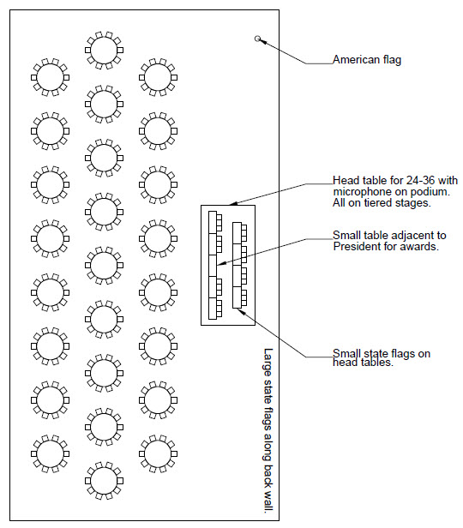
- Wednesday
- Typically Noon to 2:00 pm

Function Attendance
- See historical data ranges

Room Set up
- Rounds of 10
- Head table on low risers to seat 24-36
- Table top lectern w/microphone adjacent to President at head table
- One American Flag on left at riser
- Large State flags on back wall
- Small flags on center of tables
- One easel outside of room.

Audio/Visual
- Presidential podium microphone
- Overhead projector package
  - Projector
  - Cart
  - Screen
  - All electrical cables and cords
- Speakers and amplifiers

Food & Beverage:
Selected in consultation with LAC Chair.
May include:
- Soup or Salad
- Entrée
- Dessert
- Coffee, decaf, tea

TO BE DEVELOPED

- Banquet Layout
- Student Competition
- Vendor Layout Samples

